1. Select all the data of passengers whose last name is same as first name.

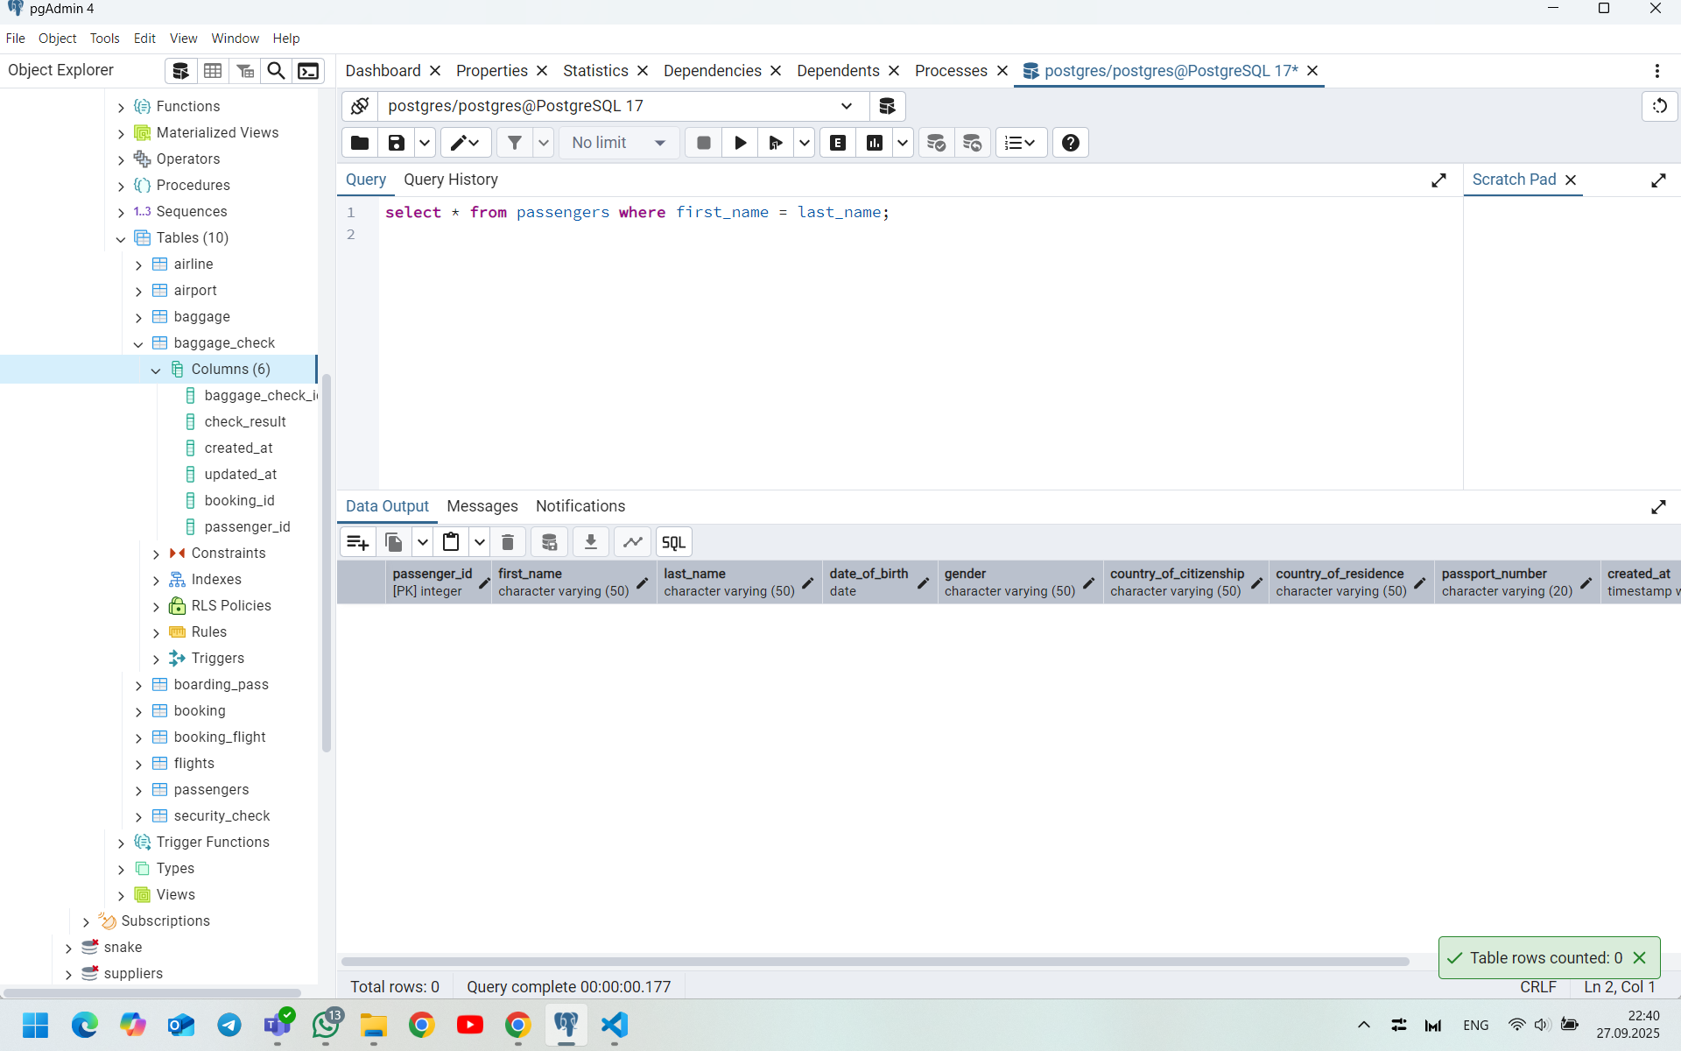

1. Select the last name of all passangers without duplicates.

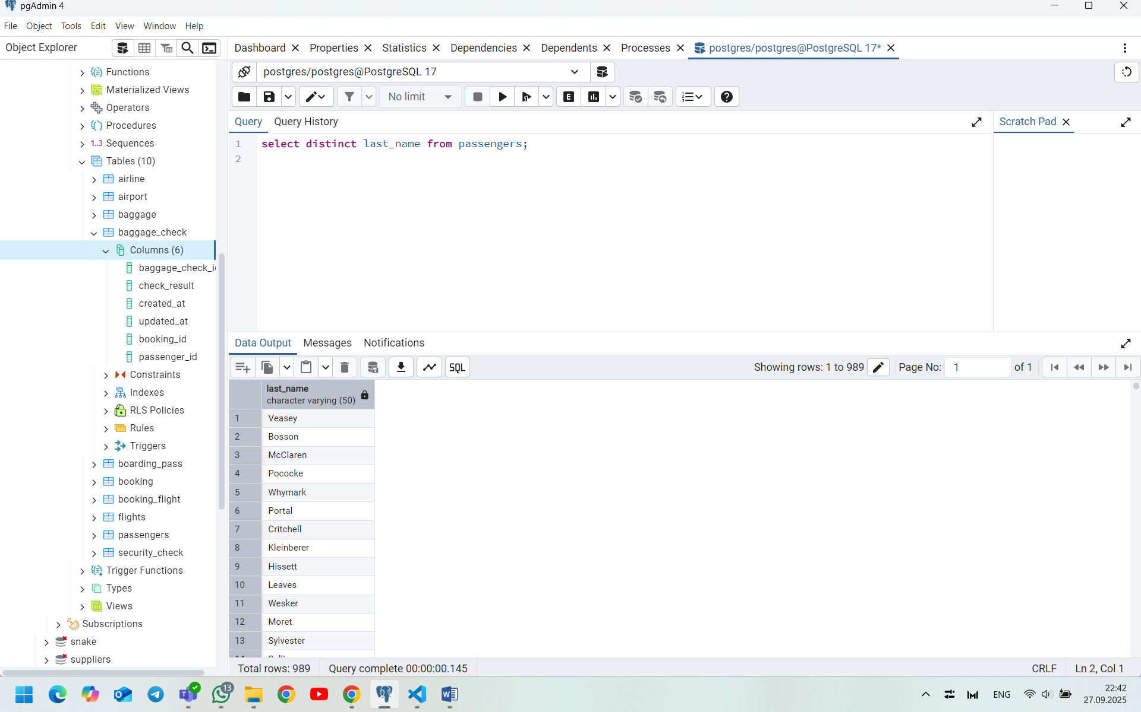

1. Find all male passengers born between 1990 and 2000.

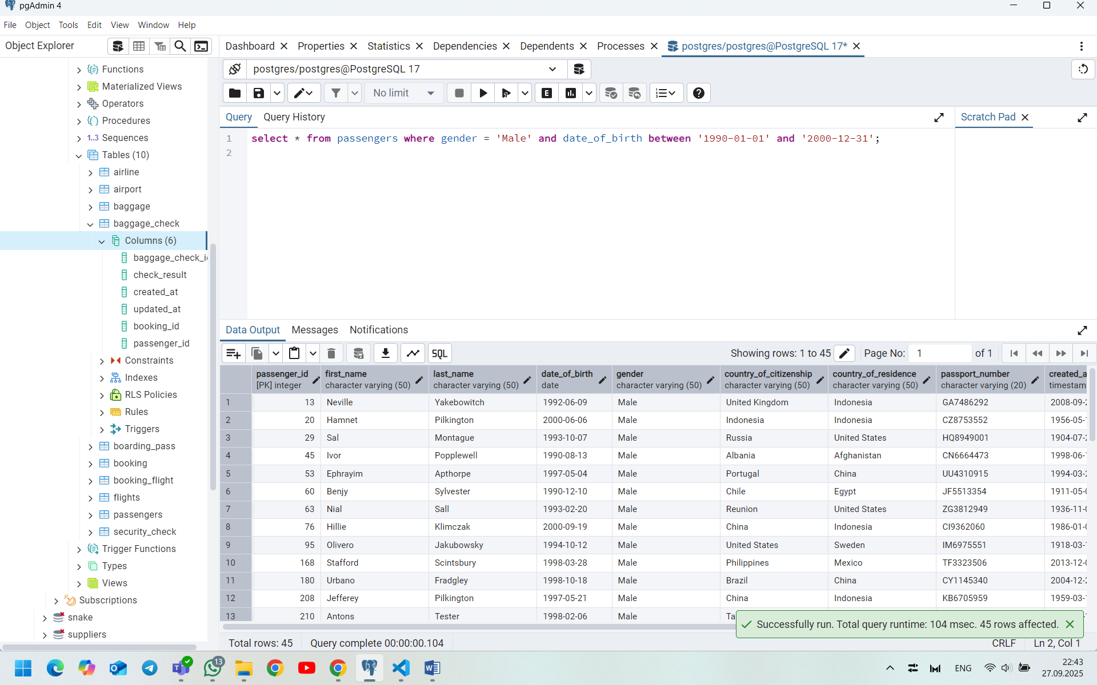

1. Find price of tickets sold for each month in sorted way.

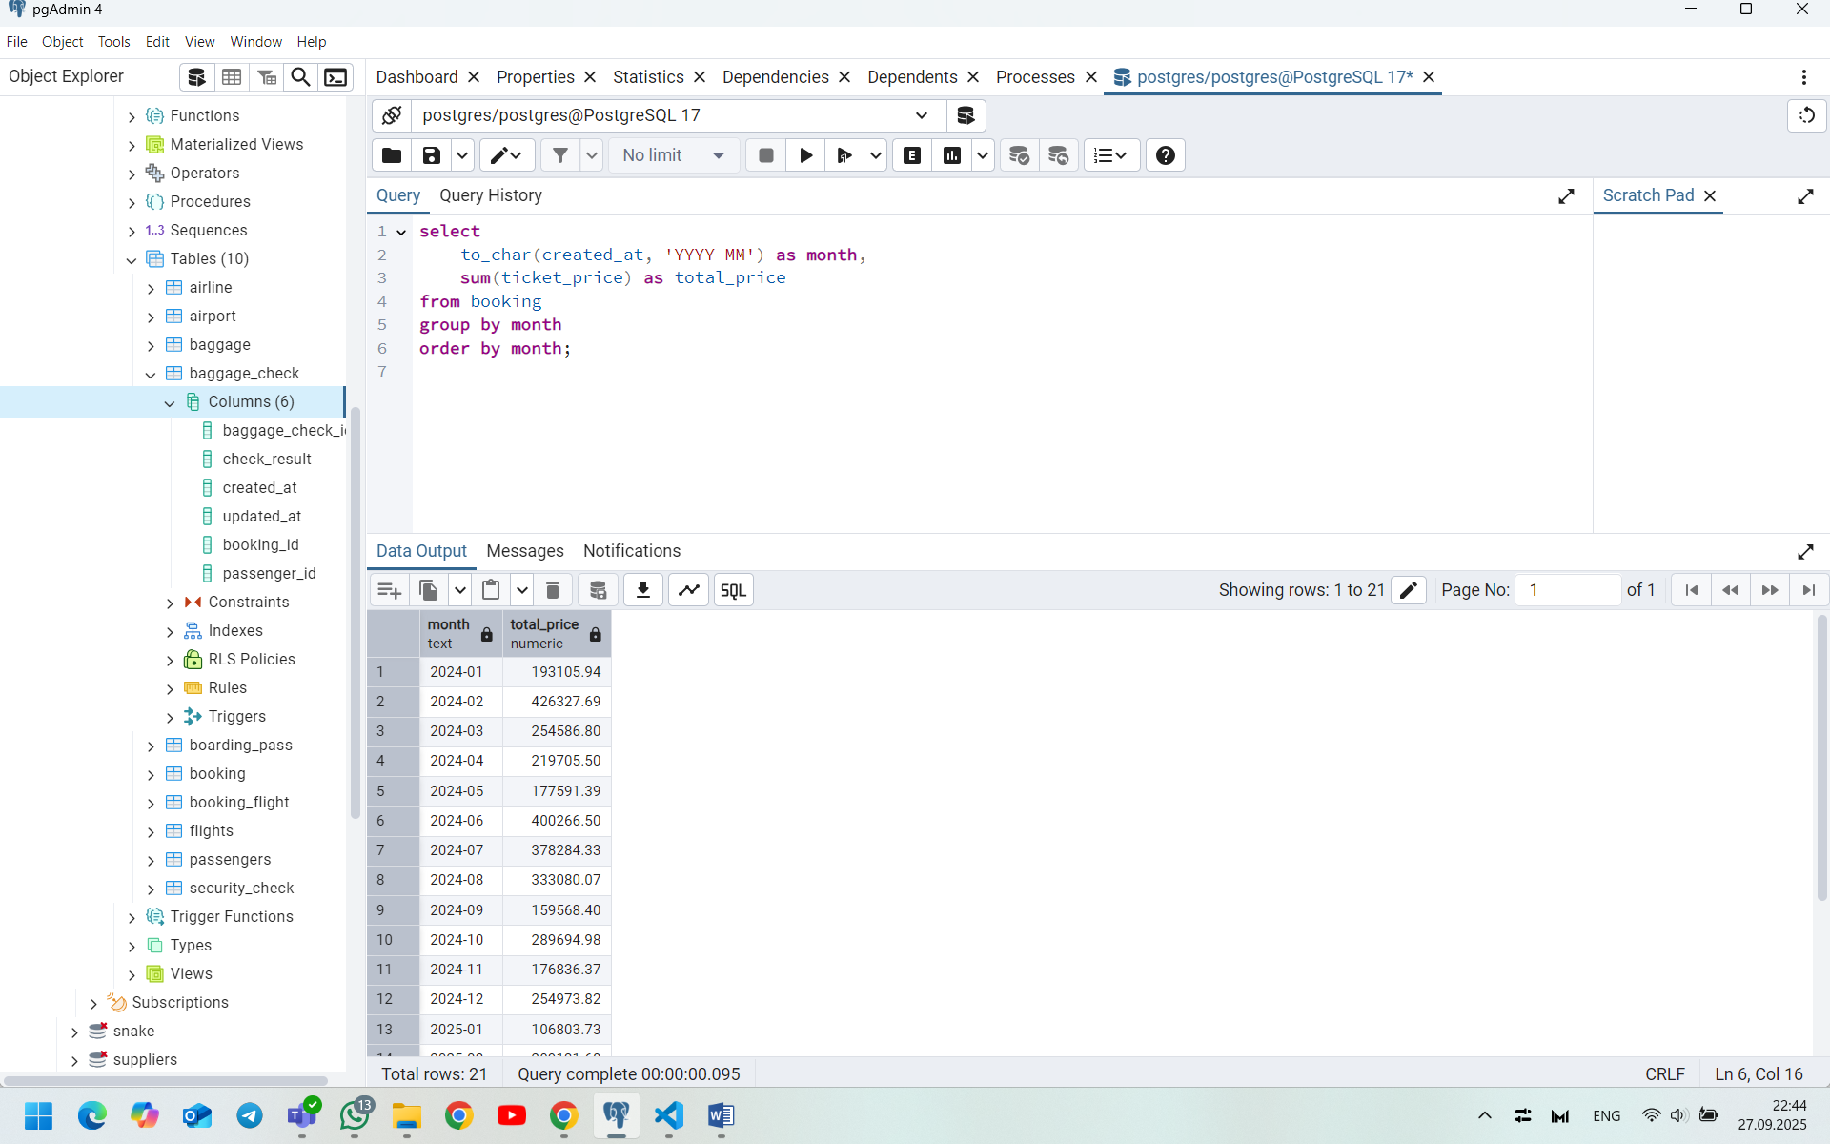

1. Create a query that shows all flights flying to ‘China’.

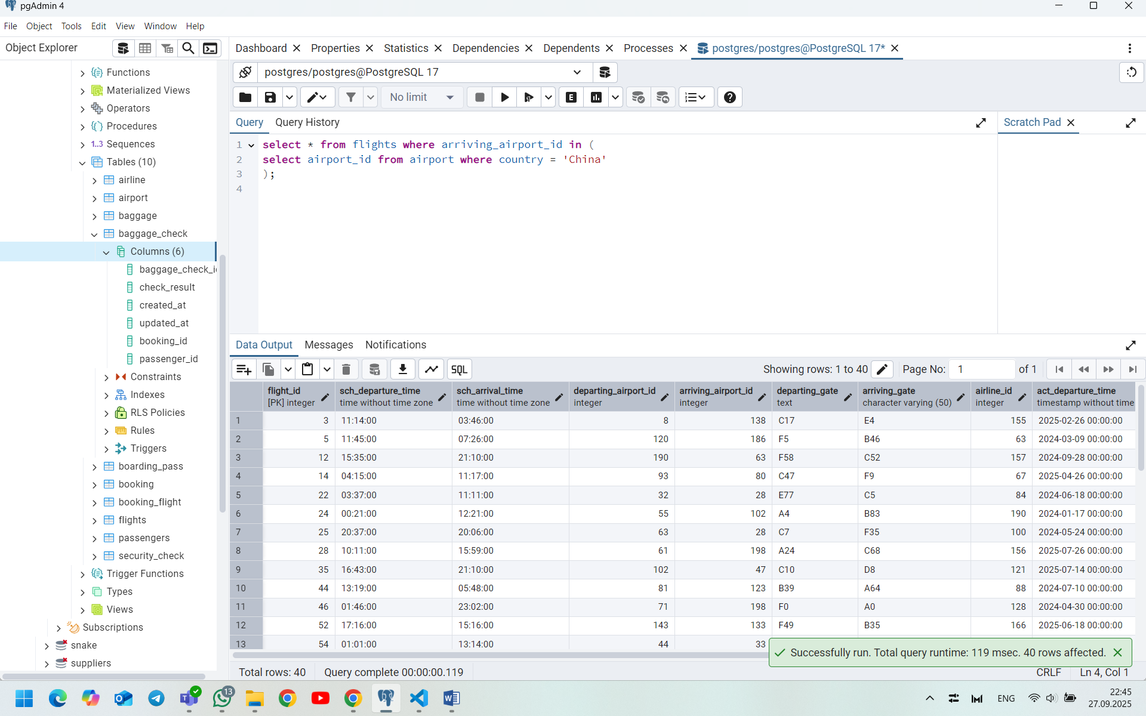

1. Show airlines from any of: ('France','Portugal','Poland') created between '2023-11-01' and '2024-03-31'.

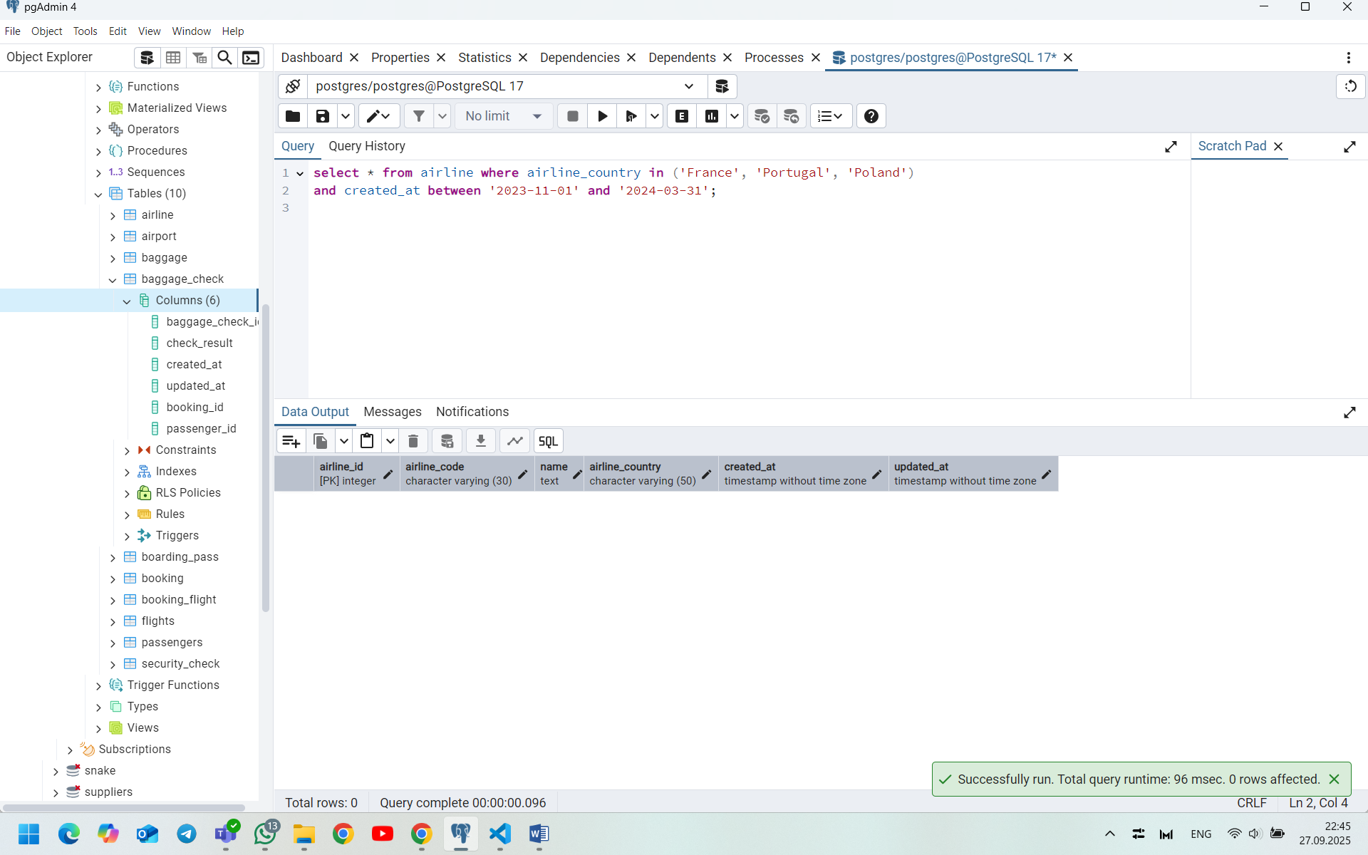

1. Find all airline names based in Kazakhstan.

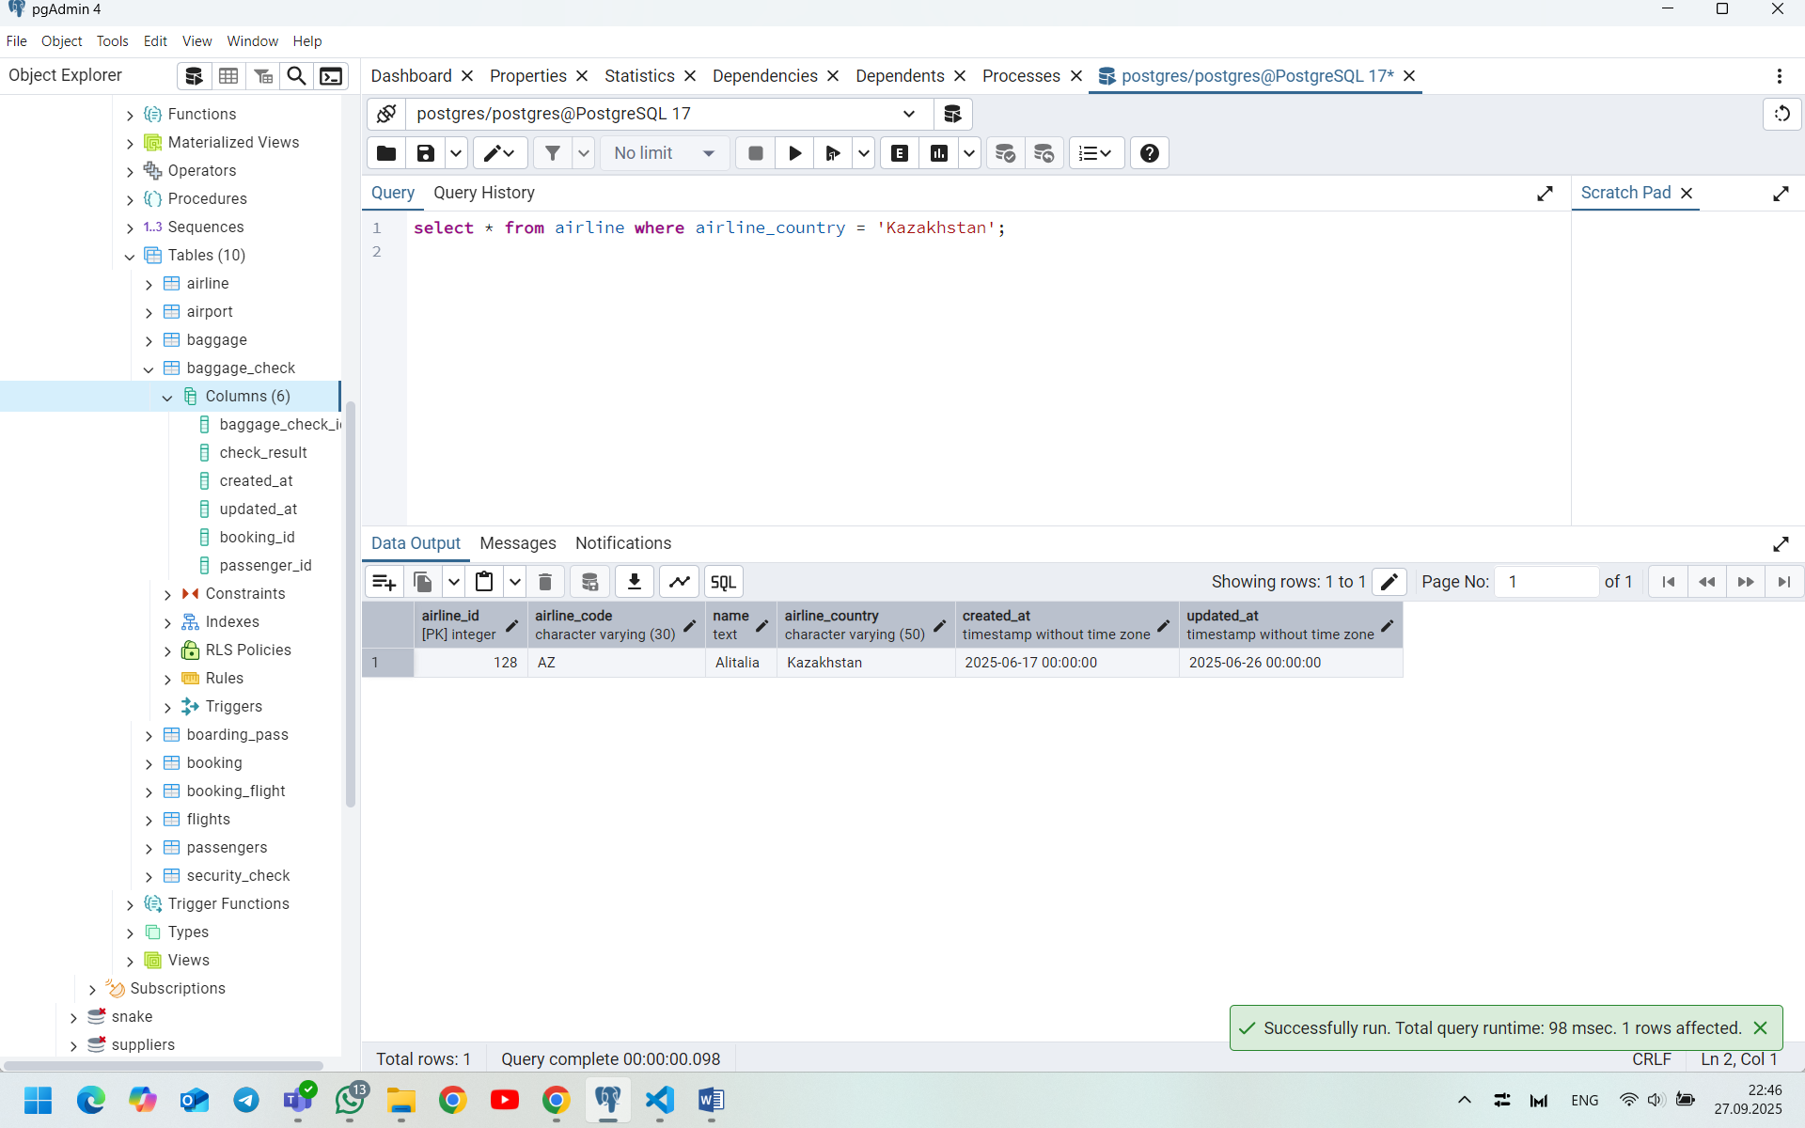

1. Reduce the cost of booking price by 10% created before ’11-01-2023’.

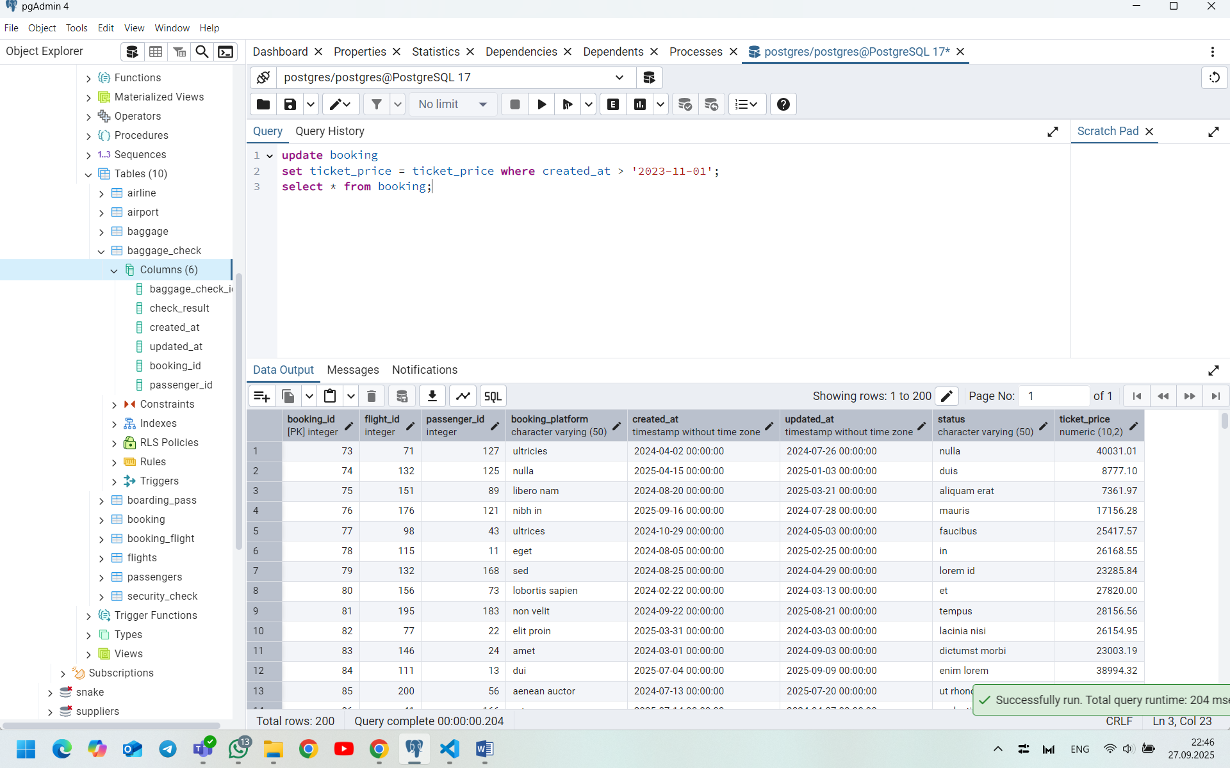

1. Find top3 overweighted baggage with more than 25kg.

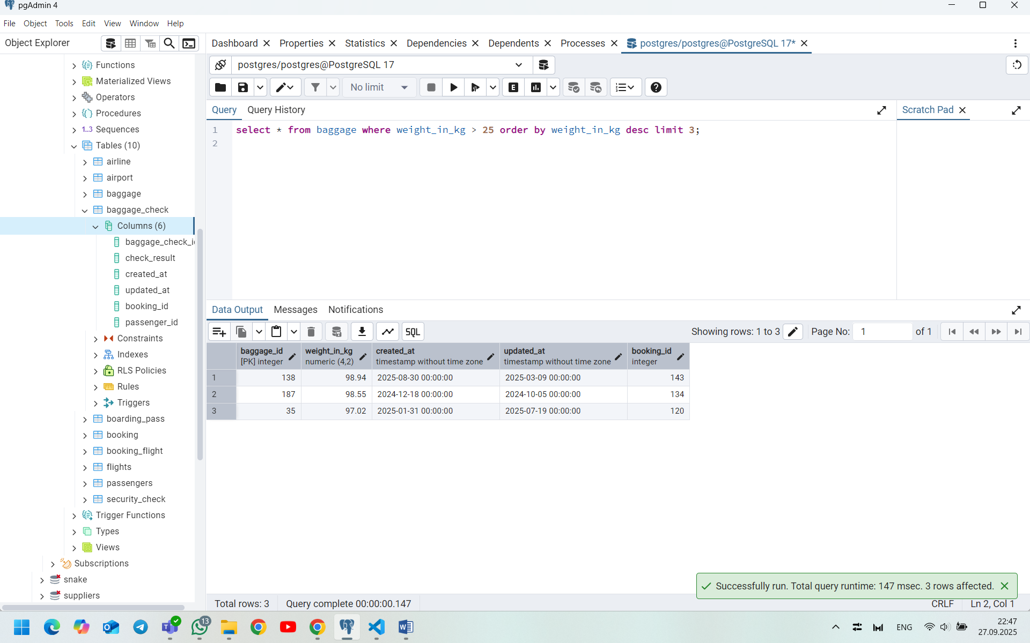

1. Find the youngest passengers’ full name.

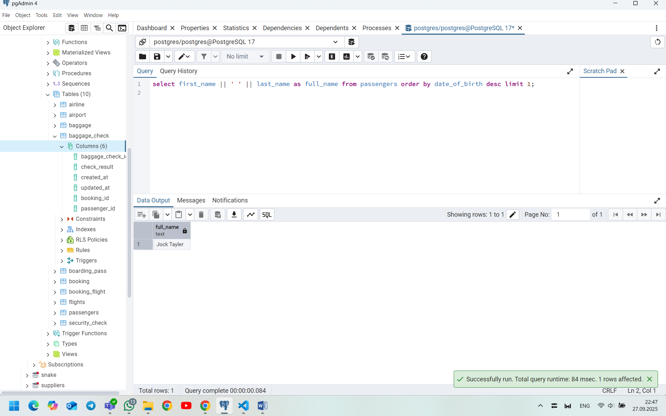

1. Find the cheapest booking price on each booking platform.

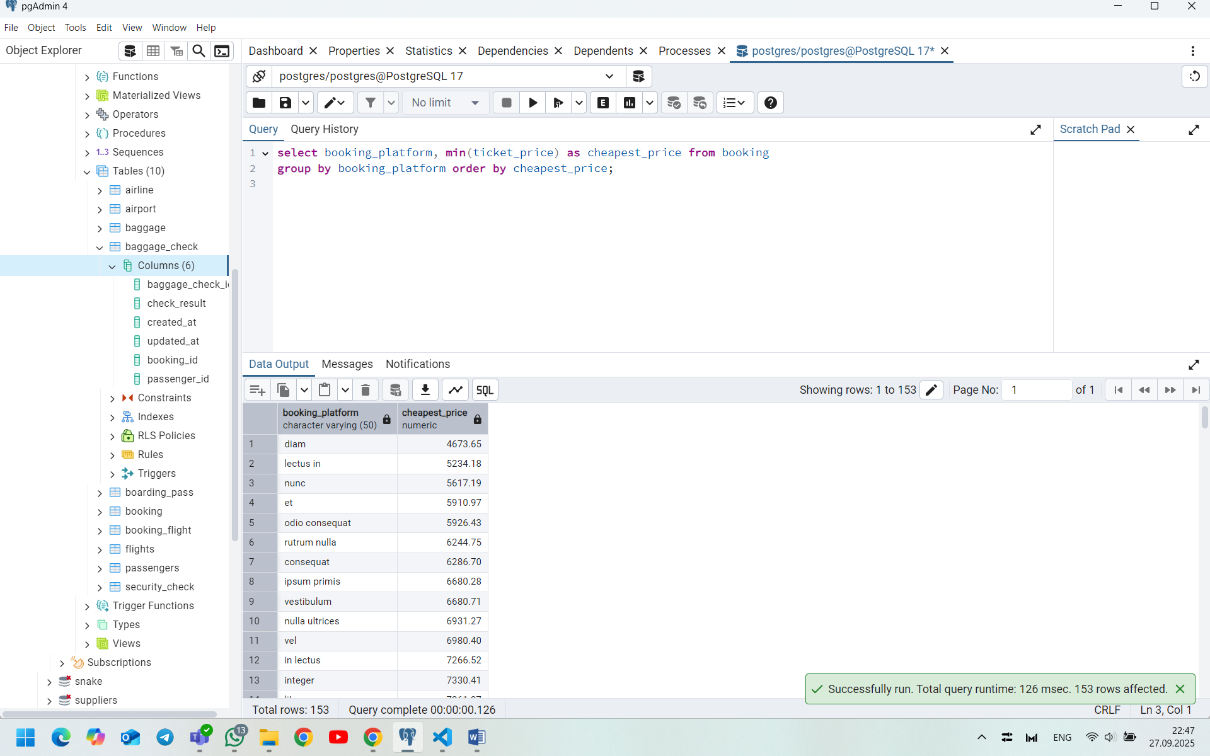

1. Return airlines whose airline_code contains a digit.

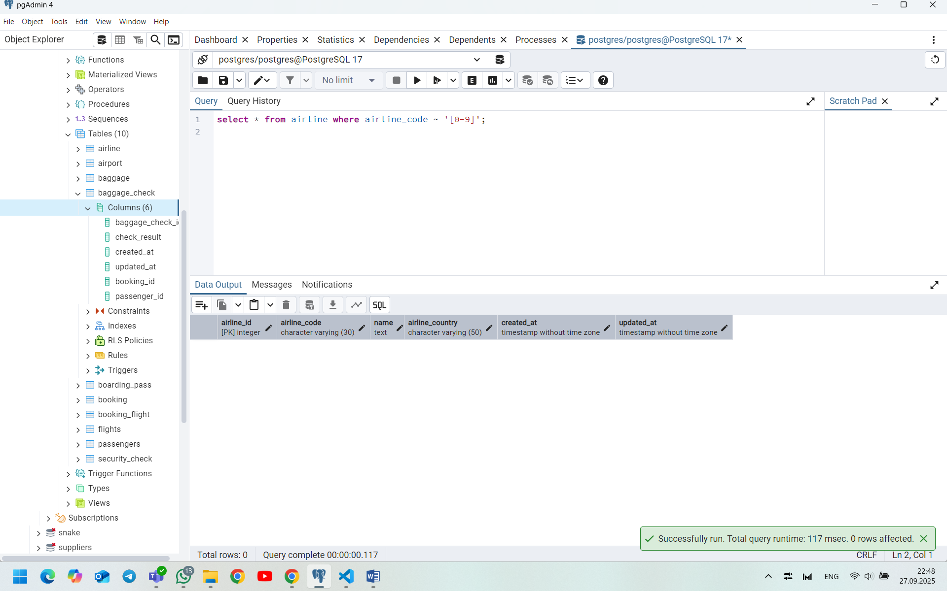

1. List the top5 most recently created airlines.

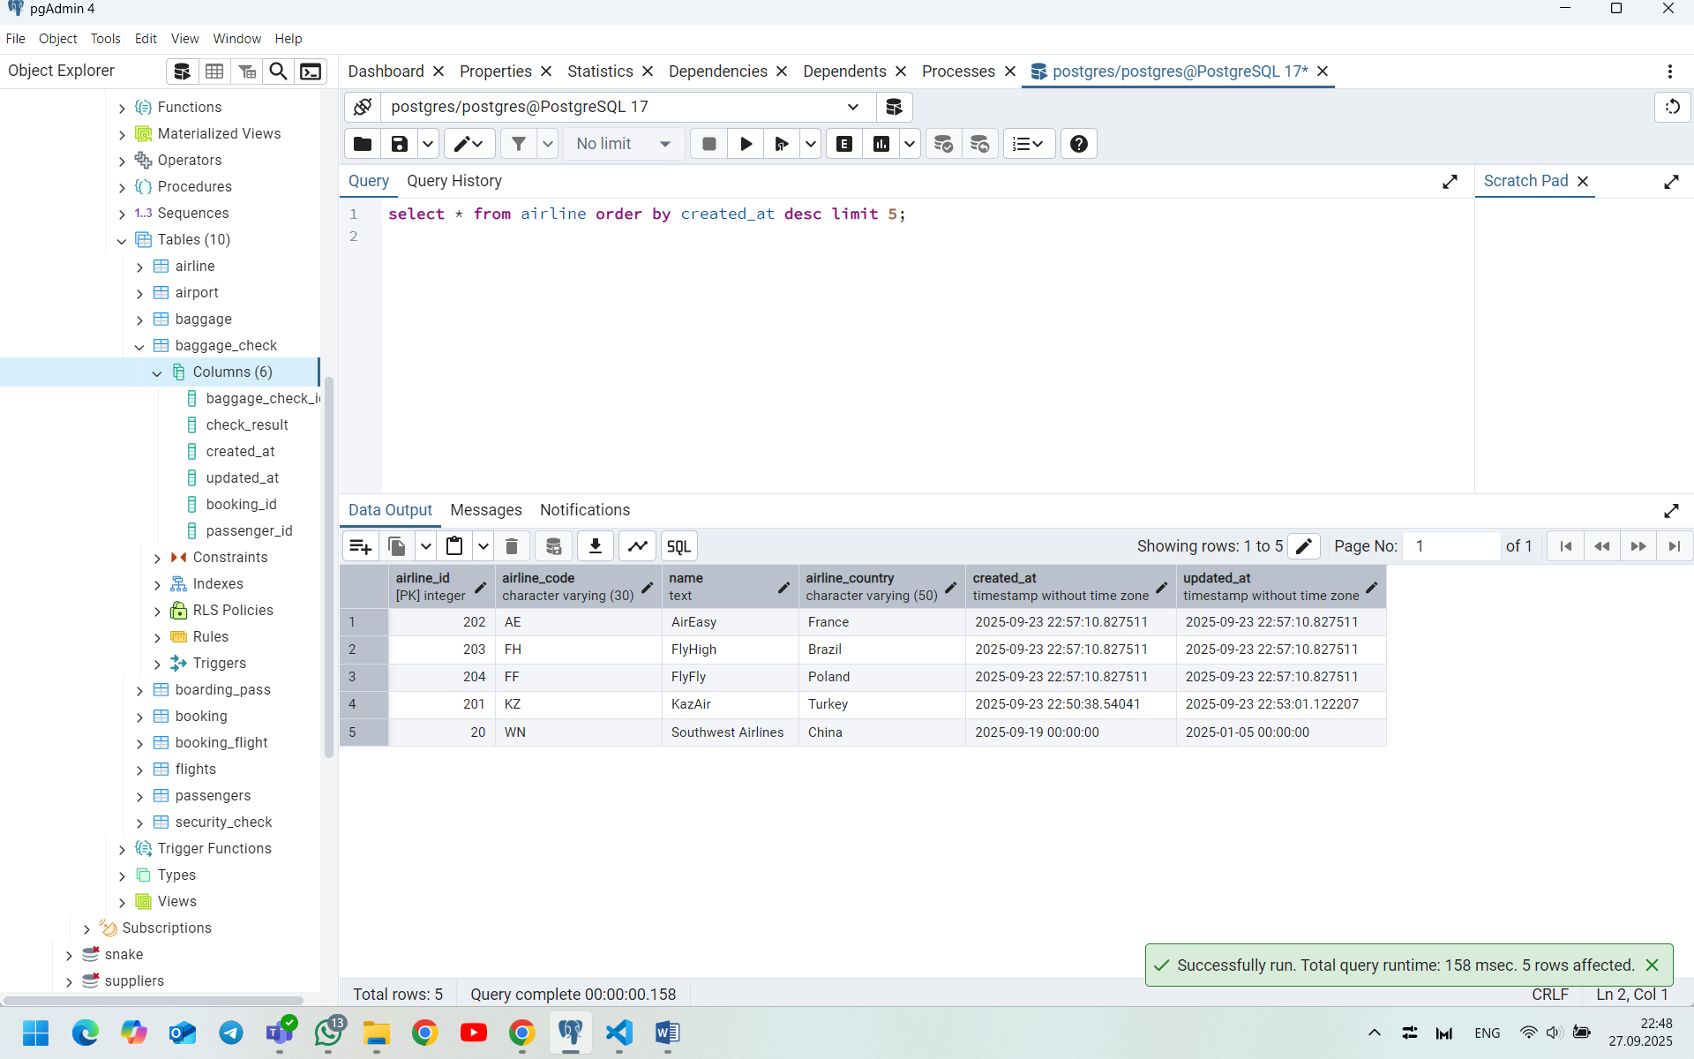

1. Return all rows where booking_id is between 200 and 300 inclusive and check_result <> 'Checked'.

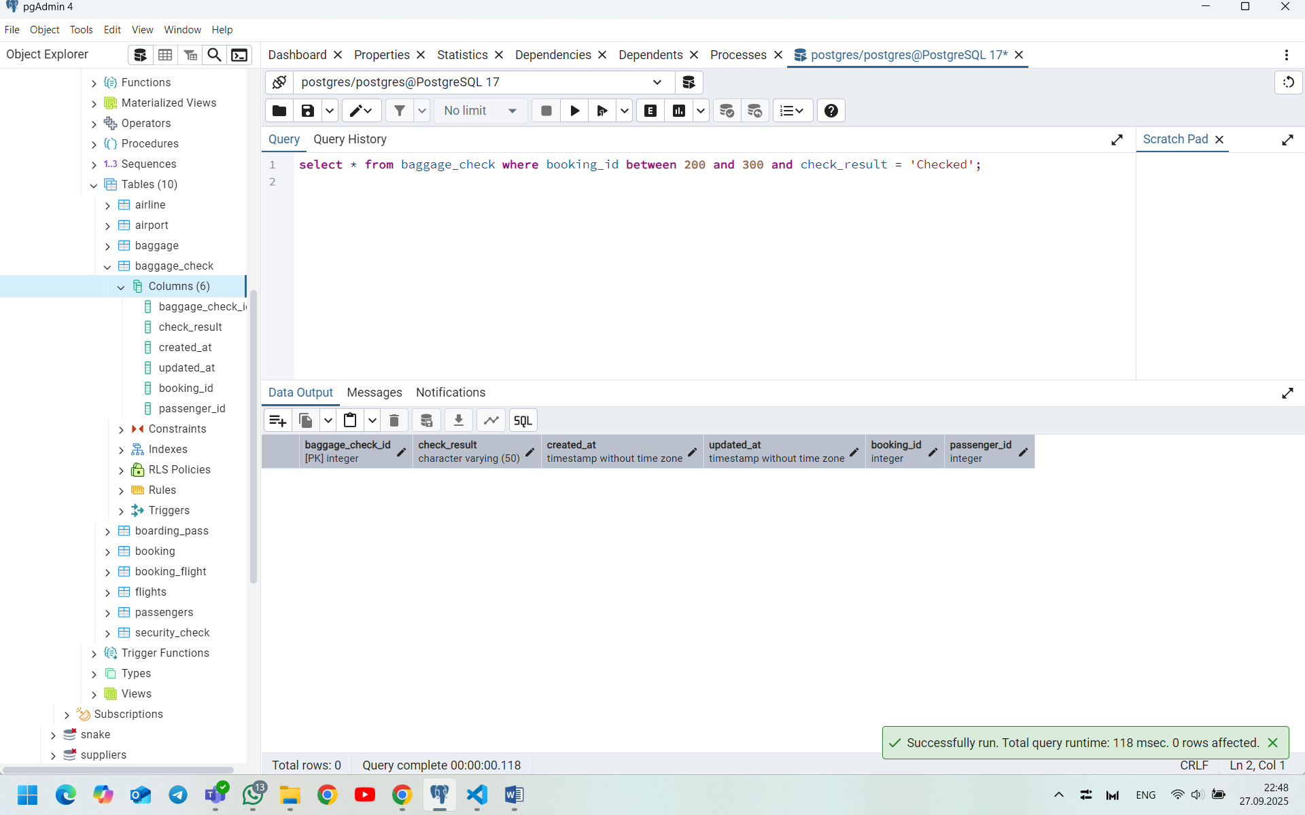

1. Baggage checks where update_at is in the same month as created_at but occurs earlier than created_at.

